scaling from zero to millions of users.

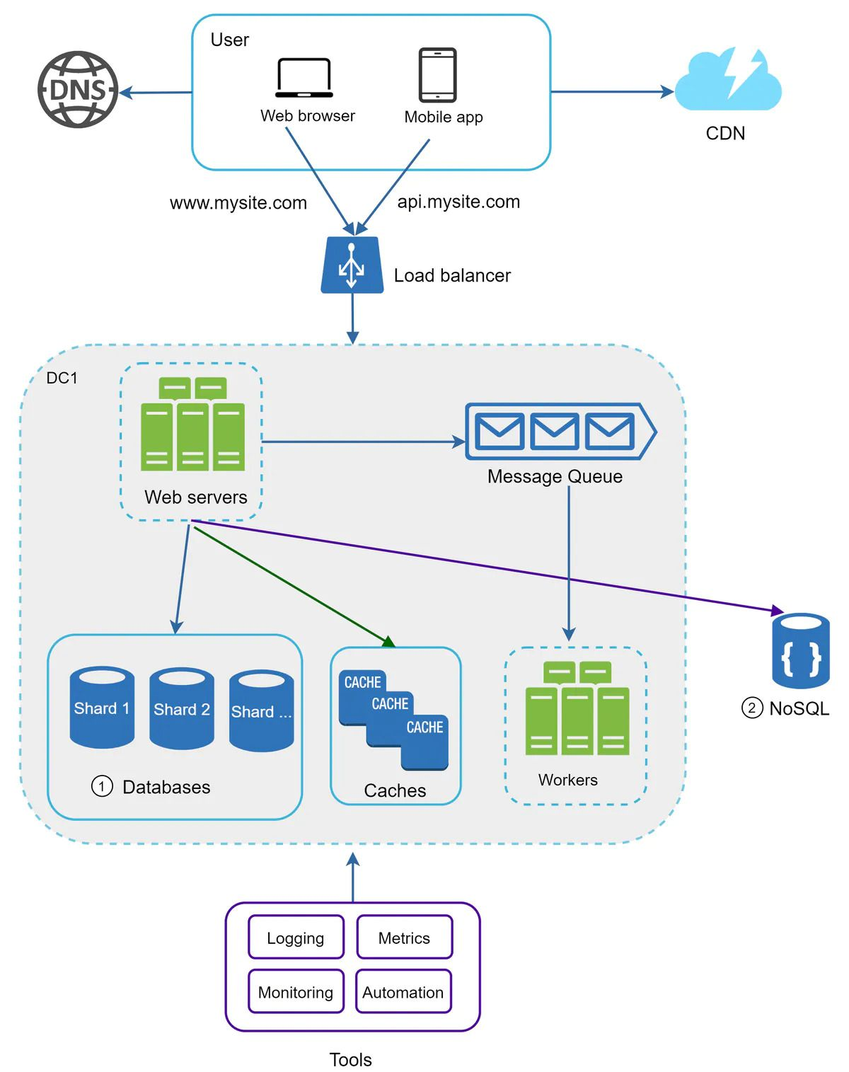

System design questions are common in DevOps Interviews.  
  
The blog starts with very basics to important scaling concepts.  
  
Here is what you can learn from the blog,  
  
1. Loadbalancer   
2. Vertical & Horizontal Scaling  
3. Database replication & Scaling  
4. Caching considerations  
5. Content Delivery Network  
6. Stateful architecture & Stateless architecture  
7. Message Queues  
8. Logging, metrics, automation  
  
Also, the reference materials listed have tons of information.  
  
Read the Full Blog: <https://bit.ly/3ztOpSo>  
  
[#devops](https://www.linkedin.com/feed/hashtag/?keywords=devops&highlightedUpdateUrns=urn%3Ali%3Aactivity%3A6940522676532711424) [#devopsengineer](https://www.linkedin.com/feed/hashtag/?keywords=devopsengineer&highlightedUpdateUrns=urn%3Ali%3Aactivity%3A6940522676532711424) [#devopsinterviewquestion](https://www.linkedin.com/feed/hashtag/?keywords=devopsinterviewquestion&highlightedUpdateUrns=urn%3Ali%3Aactivity%3A6940522676532711424) [#SRE](https://www.linkedin.com/feed/hashtag/?keywords=sre&highlightedUpdateUrns=urn%3Ali%3Aactivity%3A6940522676532711424)